*CHEM 202 Accelerated General Chemistry I TA: Alex Wang  
Week 3 – Gases I September 7th, 2021*

*MERIT WS 3.1 Section AQG*

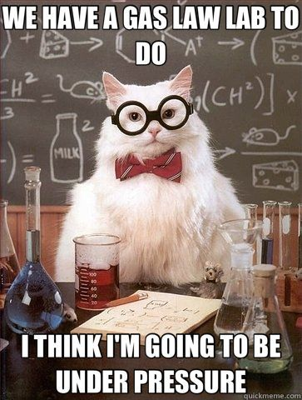

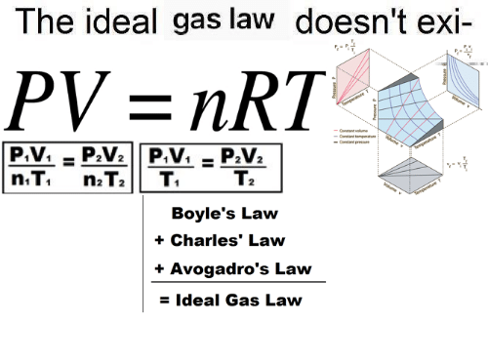

***This worksheet will set the basis of the theory for Gases. Please take part in ACTIVE discussions with your groups.***

Gases: Theoretical Perspectives

1. A diagram in a chemistry book shows a magnified view of a flask of air as follows:

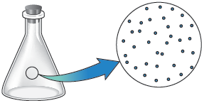

What do you suppose is between the dots (the dots represent air molecules)?

1. Air
2. Dust
3. Pollutants
4. Oxygen
5. Nothing
6. Consider 2 steel containers with the same volume, at the same temperature. You add helium gas (He) to one container and the same mass of argon (Ar) to the other. How to the pressures inside the containers compare? Explain your answer.
   1. The pressures are the same.
   2. The pressure inside the tank filled with argon is about ten times greater than the pressure inside the tank filled with helium.
   3. The pressure inside the tank filled with helium is about ten times greater than the pressure inside the tank filled with argon.
7. You have a gas in a container fitted with a piston and you change one of the conditions of the gas such that a change takes place, as shown below:

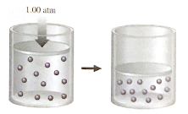

State two distinct changes you can make to accomplish this and explain why each would work.

* Change 1:
* Change 2:

1. You have a gas in a container fitted with a piston and you change one of the conditions of the gas such that a change takes place, as shown below:

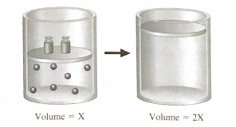

State three distinct changes you can make to accomplish this and explain why each would work.

* Change 1:
* Change 2:
* Change 3:

1. Consider the flasks in the following diagrams.

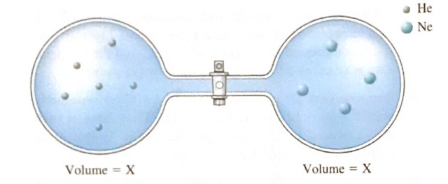

* 1. Which is greater, the initial pressure of helium or initial pressure of neon? How much greater?
  2. Assuming the connecting tube has negligible volume, draw what each diagram will look like after the stopcock between the two flasks is opened.
  3. Solve for the final pressure in terms of the original pressures of helium and neon. Assume the temperature is constant.
  4. Solve for the final partial pressures of helium and neon in terms of their original pressures. Assume the temperature is constant.

1. Rationalize the following observations.
   * Aerosol cans will explode if heated.
   * You can drink through a soda straw.
   * A thin-walled can will collapse when the air inside is removed by a vacuum pump.
   * Manufacturers produce different types of tennis balls for high and low elevations.
2. Chemicals X and Y (both gases) react to form the gas XY, but it takes a bit of time for the reaction to occur. Both X and Y are placed in a container with a piston (free to move), and you note the volume. As the reaction occurs, what happens to the volume of the container? Explain.

Gases: Mathematical Applications

1. You blow up a balloon and seal it on Monday. On Tuesday the temperature (in Celsius) is double the temperature on Monday, and the balloon is 7% larger. What was the temperature on Monday? Assume the atmospheric pressure remains constant for two days.
2. A vendor is selling balloons. She has a 6.50-L tank filled with helium at a pressure of 85.5 atm. She makes 5.50-L balloons at a pressure of 1.0 atm. How many balloons can she fill?
3. A mixture of chromium and zinc weighing 0.362 g was reacted with an excess of hydrochloric acid. After all the metals in the mixture reacted, 225 mL of dry hydrogen gas was collected at 27℃ and 750. torr. Determine the mass percent of Zn in the metal sample. [Zinc reacts with hydrochloric acid to produce zinc chloride and hydrogen gas; chromium reacts with hydrochloric acid to produce chromium(III) chloride and hydrogen gas.
4. A steel cylinder contains 5.00 moles of graphite (pure carbon) and 5.00 moles of O2. The mixture is ignited, and all the graphite reacts. Combustion produces a mixture of CO gas and CO2 gas. After the cylinder has cooled to its original temperature, it is found that the pressure of the cylinder has increased by 17.0%. Calculate the mole fractions of CO, CO2, and O2 in the final gaseous mixture.

CHEM 202 Fall 2017 Hour Exam I Free Response

1. Consider three binary gaseous compounds (A,B, and C) at room conditions (1.00 atm and 25OC) made from the same two elements (X and Z). You have the following data on two of the compounds:

|  |  |  |
| --- | --- | --- |
| Compound | Density | Mass % of Z |
| A | 3.106 g/L | 63.2% |
| B | 4.416 g/L | 74.1% |

You also have a mixture of equal masses of gas B and gas C, and this gaseous mixture has a density of 2.639g/L (at 1.00 atm and 25OC).

Your goal is to **determine the molecular formulas for the three compounds.**

If you believe that there are multiple possible answers for a given compound, list the choices and support them.

Please **fully explain and how all work in a systematic fashion.**