*CHEM 202 Accelerated General Chemistry I TA: Alex Wang  
Week 4 – Gases III September 14th, 2020*

*MERIT WS 4.1 Section AQG*

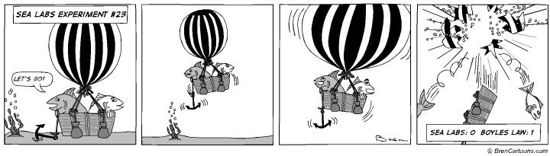

1. You are holding two balloons of equal volume, one filled with SF6(*g*) and the other with He(*g*). How do the collision rates of gas particles with the inside of the balloon compare?
   1. The collision rate of the He atoms is greater than the collision rate of SF6 molecules. Thus, the pressure is greater in the balloon filled with He.
   2. The collision rate of the SF6 atoms is greater than the collision rate of He molecules. Thus, the pressure is greater in the balloon filled with He.
   3. The pressures of the gases are equal so the collision rates must be the same.
   4. The collision rate of the SF6 molecules is greater than the collision rate of He atoms but the pressures are the same in the balloons.
   5. The collision rate of the He molecules is greater than the collision rate of SF6 atoms but the pressures are the same in the balloons.
2. Calculate the average kinetic energy and root mean square velocity of oxygen molecules at 22°C. At what temperature will a sample of sulfur hexafluoride molecules have the same root mean square velocity?
3. As you increase the temperature of a gas in a sealed, rigid container, what happens to the density of the gas? Would the results be the same if you did the same experiment in a container with a piston at constant pressure? Explain.
4. You have two containers each with 1 mole of xenon gas at 15°C. Container A has a volume of 3.0 L, and container B has a volume of 1.0 L. Explain how the following quantities compare between the two containers.
   1. The average kinetic energy of the Xe atoms
   2. The force with which the Xe atoms collide with the container walls
   3. The root mean square velocity of the Xe atoms
   4. The collision frequency of the Xe atoms (with other atoms)
   5. The pressure of the Xe sample
5. A 250.0 L cylinder contains 65% He and 35% Kr by mass at 25°C and 1.35 atm total pressure. What is the partial pressure of He in this container?
6. A 2.747-g sample of manganese metal is reacted with excess HCl gas to produce 3.22 L of H2(*g*) at 373 K and 0.951 atm and a manganese chloride compound (MnCl*x*). What is the formula of the manganese chloride compound produced in the reaction?
7. A bicycle tire is filled with air to a pressure of 75 psi at a temperature of 19°C. Riding the bike on asphalt on a hot day increases the temperature of the tire to 58°C. The volume of the tire increases by 4.0%. What is the new pressure in the bicycle tire?
8. In a mixture of two gases, the partial pressures of methane and oxygen are 0.175 atm and 0.250 atm, respectively.
   1. What is the mole fraction of each gas in the mixture?
   2. If the mixture occupies a volume of 10.5 L at 65°C, calculate the total number of moles of gas in the mixture.
   3. Calculate the number of grams of each gas in the mixture.
9. In this problem you will differentiate between a law and a theory and apply your results.
   1. Starting with the ideal gas law equation, **derive an equation** (law) relating the moles of gas to the Kelvin temperature at a given pressure and volume. **Show all steps.**
   2. **Sketch a plot** of n (y) vs. T (K) (x) at constant P and V. **Explain** how your graph supports the law you derived in part a.
   3. Use the tenets of the kinetic molecular theory to explain the law you derived in part a. Use complete sentences.
   4. A hot-air balloon is open at the bottom and top. Even after a hot-air balloon reaches maximum volume it will ascend when the air inside is heated. Use the law (part a) and theory (part c) to explain why this is true. Use complete sentences.
   5. You heat the air in a hot-air balloon to 65°C. Determine the volume (in liters) required for this balloon to be able to lift 25.0 kg if the surrounding conditions are 25°C and 1.00 atm. Assume air is 21.0% oxygen gas and 79.0% nitrogen gas by volume. Show all work.