CHEM 202 Accelerated General Chemistry I TA: Isaiah Lopez

Week 3 – Gases I September 7th, 2021

MERIT Section AQH

1. Chemicals X and Y (both gases) react to form the gas XY, but it takes a bit of time for the reaction to occur. Both X and Y are placed in a container with a piston (free to move), and you note the volume. As the reaction occurs, what happens to the volume of the container? Explain.
2. Rationalize the following observations.
   1. Aerosol cans will explode if heated.
   2. You can drink through a soda straw.
   3. A thin-walled can will collapse when the air inside is removed by a vacuum pump.
   4. Manufacturers produce different types of tennis balls for high and low elevations.
3. Show how Boyle’s law and Charles’s law are special cases of the ideal gas law.
4. Consider the flasks in the following diagram.

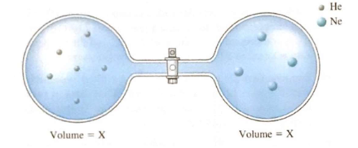

* 1. Which is greater, the initial pressure of helium or initial pressure of neon? How much greater?
  2. Assuming the connecting tube has negligible volume, draw what each diagram will look like after the stopcock between the two flasks is opened.
  3. Solve for the final pressure in terms of the original pressures of helium and neon. Assume temperature is constant.
  4. Solve for the final partial pressures of helium and neon in terms of their original pressures. Assume the temperature is constant.

1. You have a gas in a container fitted with a piston and you change of the conditions of the gas such that a change takes place, as shown below:

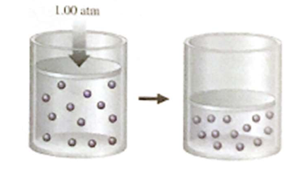

State two distinct changes you can make to accomplish this, and explain why each would work.

1. You have a gas in a container fitted with a piston and you change one of the conditions of the gas such that a change takes place, as shown below:

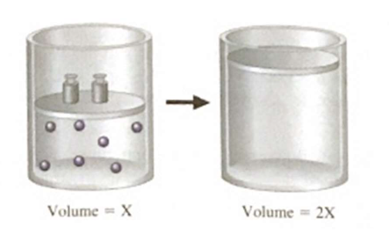

State three distinct changes you can make to accomplish this, and explain why each would work.

1. Consider 2 steel containers with the same volume, at the same temperature. You add helium gas (He) to one container and the same mass of argon gas (Ar) to the other. How do the pressures inside the containers compare? Explain your answer.
   1. The pressures are the same.
   2. The pressures inside the tank filled with argon is about ten times greater than the pressure inside the tank filled with helium.
   3. The pressure inside the tank filled with helium is about ten times greater than the pressure inside the tank filled with argon.
2. You blow up a balloon and seal in on Monday. On Tuesday, the temperature (in Celsius) is double the temperature on Monday, and the balloon is 7% larger. What was the temperature on Monday? Assume atmospheric pressure remains constant for the two days.
3. A vendor is selling balloons. She has a 6.50-L tank filled with helium at a pressure of 85.5 atm. She makes 5.50-L balloons at a pressure of 1.0 atm. How many balloons can she fill?
4. A mixture of chromium and zinc weighing 0.362 g was reacted with an excess of hydrochloric acid. After all the metals in the mixture reacted, 225 mL of dry hydrogen gas was collected at 27 °C and 750. torr. Determine the mass percent of Zn in the metal sample. [Zinc reacts with hydrochloric acid to produce zinc chloride and hydrogen gas; chromium reacts with hydrochloric acid to produce chromium(III) chloride and hydrogen gas.]
5. A steel cylinder contains 5.00 moles of graphite (pure carbon) and 5.00 moles of O2. The mixture is ignited, and all the graphite reacts. Combustion produces a mixture of CO gas and CO2 gas. After the cylinder has cooled to its original temperature, it is found that the pressure of the cylinder has increased by 17.0%. Calculate the mole fractions of CO, CO2, and O2 in the final gaseous mixture.