CHEM 202 Accelerated General Chemistry I TA: Isaiah Lopez

Week 4 – Gases III September 14th, 2021

MERIT Section AQH

1. Match the statements provided below with the graphical representations shown.

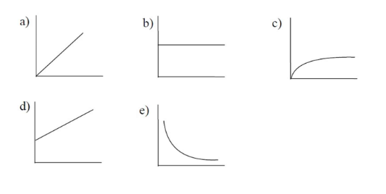

1. Density (y) vs. T(K) (x) for 1 mole of an ideal gas in a rigid steel container
2. Pressure (y) vs. molar mass (x) for 1 mole of a given volume of a series of ideal gases at the same temperature.
3. A mixture of chromium and zinc weighing 0.362 g was reacted with an excess of hydrochloric acid. After all the metals in the mixture reacted, 225 mL of dry hydrogen gas was collected at 27 °C and 750. torr. Determine the mass percent of Zn in the metal sample. [Zinc reacts with hydrochloric acid to produce zinc chloride and hydrogen gas; chromium reacts with hydrochloric acid to produce chromium(III) chloride and hydrogen gas.]
4. For which of the following constant volume cases is the number of collisions of gas particles with the walls of the container the greatest? Volume is the same in all cases.
   1. 1.0 mol of oxygen gas at 25°C
   2. 1.0 mol of oxygen gas at 125°C
   3. 1.0 mol of helium gas at 25°C
   4. 1.0 mol of helium gas at 125°C
   5. Choices a and b have equal collision rates, and these are higher than those in c and d.
5. What mass of carbon dioxide will exert twice the pressure of 150.0 g of helium gas at the same conditions of volume and temperature?

a) 13.64 g b) 150.0 g c) 1.649 kg d) 3.298 kg e) 4.185 kg

1. You are holding two balloons of equal volume, one filled with SF6(g) and the other with He(g). How do the collision rates of gas particles with the inside of the balloon compare?
   1. The collision rate of the He atoms is greater than the collision rate of SF6 molecules. Thus, the pressure is greater in the balloon filled with He.
   2. The collision rate of the SF6 atoms is greater than the collision rate of He molecules. Thus, the pressure is greater in the balloon filled with He.
   3. The pressures of the gases are equal so the collision rates must be the same.
   4. The collision rate of the SF6 molecules is greater than the collision rate of He atoms but the pressures are the same in the balloons.
   5. The collision rate of the He molecules is greater than the collision rate of SF6 atoms but the pressures are the same in the balloons.
2. Consider a gas mixture consisting of xenon and neon at 3.14 atm and 25.0 °C. The density of this mixture is 11.15 g/L. Determine the partial pressure of the xenon.
3. 1.14 atm b) 1.26 atm c) 1.57 atm d) 1.88 atm e) More info needed.
4. A gas at 323°C has the same rate of effusion as H2(g) at 25°C. Which of the following could be that gas?

a) SF6(g) b) C2H2(g) c) SO2(g) d) O3(g) e) He(g)

1. When solid potassium chlorate (KClO3) is heated, the products are potassium chloride and oxygen gas. A sample of potassium chlorate is heated to completion and 2.83 L of pure oxygen gas is collected at 1.00 atm and 25°C. Determine the mass of solid product.

a) 5.75 g b) 8.63 g c) 9.45 g d) 12.94 g e) 17.2 g

1. Indicate which of the graphs below best represents each plot described in questions I-IV. Note: the graphs may be used once, more than once, or not at all.

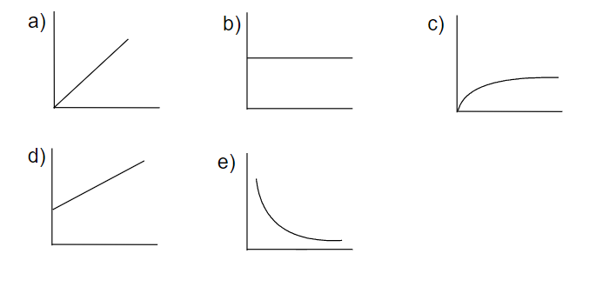

1. Pressure vs. molar mass for 100.0-g samples of different ideal gases at constant V, T.
2. Collision frequency (ZA) (y) vs. P (x) for an ideal gas at constant V and T.
3. Gas density (y) vs. T(x) for 1.0 mol of an ideal gas at constant P.
4. Collision frequency (ZA) (y) vs. T (x) for 1.0 mol of an ideal gas at constant V.
5. You have two containers each with 1 mole of xenon gas at 15°C. Container A has a volume of 3.0 L, and container B has a volume of 1.0 L. Explain how the following quantities compare between the two containers.
   1. The average kinetic energy of the Xe atoms
   2. The force with which the Xe atoms collide with the container walls
   3. The root mean square velocity of the Xe atoms
   4. The collision frequency of the Xe atoms (with other atoms)
   5. The pressure of the Xe sample
6. Consider separate 1.0-L gaseous samples of H2, Xe, Cl2, and O2, all at STP.
   1. Rank the gases in order of increasing average kinetic energy.
   2. Rank the gases in order of increasing average velocity.
   3. How can separate 1.0-L samples of O2 and H2 both have the same average velocity?