*CHEM 202 Accelerated General Chemistry I TA: Alex Wang  
Week 13 – Chemical Kinetics II November 18, 2021 2021 MERIT WS 13.2 Section AQG*

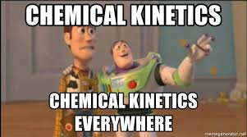

1. **Chapter 15: 50, 69, 98, 99**
2. A certain reaction has an activation energy of 54.0 kJ/mole. As the temperature is increased from 22°C to a higher temperature, the rate constant increases by a factor of 7.00. Calculate the higher temperature.
3. The following elementary steps are proposed for a reaction mechanism:
4. NO2Cl(g) → NO2(g) + Cl(g)
5. NO2Cl(g) + Cl(g) → NO2(g) + Cl2(g)
6. Write the balanced equation.
7. Determine the molecularity of each step.
8. Write the rate law for each step.
9. What step would be more likely to be the slow step? Why? Write the rate law for the overall reaction with this assumption
10. The gas-phase reaction between Br2 and H2 to form HBr is assumed to proceed by the following mechanism:

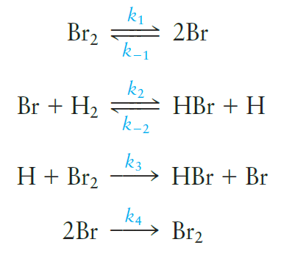

* 1. Under what conditions does the rate law have the form rate = k’[Br2]?
  2. Under what conditions does the rate law have for form rate = k”[H2][Br2]1/2?
  3. Give expressions for the k’ and k” in terms of the rate constants used to define the mechanism.

1. A certain reaction has an activation energy of 54.0 kJ/mole. As the temperature is increased from 22°C to a higher temperature, the rate constant increases by a factor of 7.00. Calculate the higher temperature.
2. Why does a catalyst increase the rate of a reaction? What is the difference between a homogeneous and a heterogeneous catalyst? Would a given reaction necessarily have the same rate law for both a catalyzed and uncatalyzed pathway? Explain.
3. Given the mechanism of catalytic hydrogenation provided below, would you predict that the product of the reaction of C2H4 with D2 would be CH2D – CH2D or CHD2 – CH3?

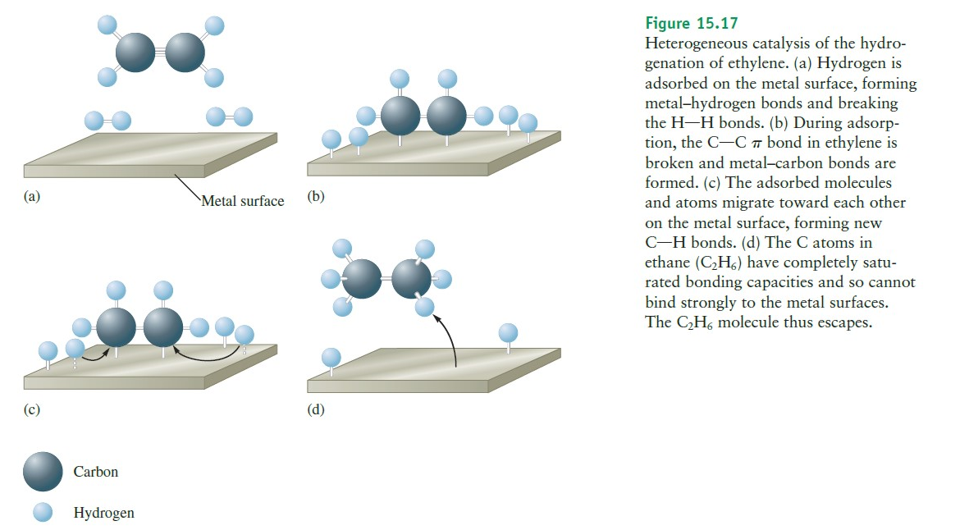

1. 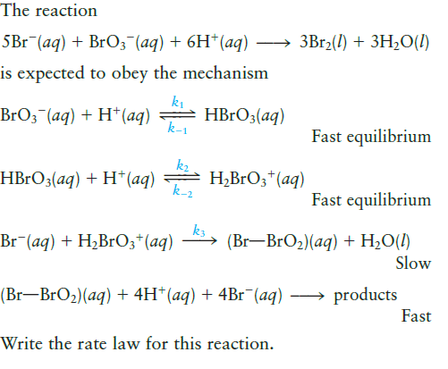
2. The following reaction is a key reaction in the upper atmosphere:

O3(*g*) + O(*g*) → 2O2(g)

The Ea(fwd) is 19 kJ and the ΔHrxn as written is -392 kJ. Draw a reaction energy diagram, predict a structure for the transition state, and calculate Ea(rev)

1. Many biochemical reactions are catalyzed by large protein molecules called enzymes. A typical mechanism for the conversion of a biochemical substrate (S) to product (P) catalyzed by an enzyme (E) involves the following steps:

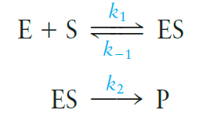

The rate-determining step is the decomposition of the intermediate enzyme–substrate complex (ES) to products (P). Under these conditions, show that the overall rate of product formation is

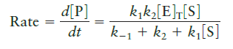

where [E]T equals the total enzyme concentration:

[E]T = [E] + [ES]

1. Consider a reaction aA→ products, in which the rate law is found to be rate = $k{[A]}^{3}$ (termolecular reactions are improbable put possible). If the first half-life of the reaction is found to be 40 seconds, what is the time for the second half-life?

Hint: Using your calculus knowledge, derive the integrated rate law from the differential rate law for a termolecular reaction: $\frac{-d[A]}{dt}=k{[A]}^{3}$