## CHEMISTRY 101 Name ______________________________

Hour Exam I

September 20, 2022 Signature ___________________________

McCarren

Section _____________________________

***“What you do makes a difference, and you have to decide what kind of difference you want to make.” – Jane Goodall***

This exam contains 27 questions. The first 15 questions are multiple choice, and the remaining questions may be numerical entry, free response, or drop down questions. Please be sure to answer all questions before submitting the exam. A periodic table is attached to this equation sheet and you may also use it as scratch paper.

Useful Information:

PV = nRT K = C + 273

R = 0.08206 L•atm/mol•K ≈ 0.0821 L•atm/mol•K Density = mass / volume

Avogadro’s number = 6.022 × 1023

1 L = 1000 mL

1 atm = 760. torr

Assume atmospheric pressure is 1.00 atm (unless explicitly told otherwise).

Always assume ideal behavior for gases (unless explicitly told otherwise).

**Part 1: Multiple Choice**

1. Current gas prices in Champaign are around $4.00 per gallon. If you are driving a car which is able to drive about 32.0 miles per gallon of gas, about how many miles are you able to drive on $30.00 worth of gas?
   1. 960. miles
   2. 288 miles
   3. 240. miles
   4. 67.5 miles
   5. 26.7 miles
2. A graduated cylinder has a water level of 7.16 mL. You drop in a piece of metal with mass 19.3 g. The water level in the graduated cylinder rises to 10.50 mL. What is the identity of the metal?
   1. Beryllium (density: 1.85 g/mL)
   2. Aluminum (density: 2.70 g/mL)
   3. Arsenic (density: 5.78 g/mL)
   4. Copper (density: 8.93 g/mL)
   5. Gold (density: 19.3 g/mL)
3. The diagram below shows representations of the contents of two boxes containing different arrangements of carbon and oxygen atoms. Which of the following statements is true regarding these boxes?

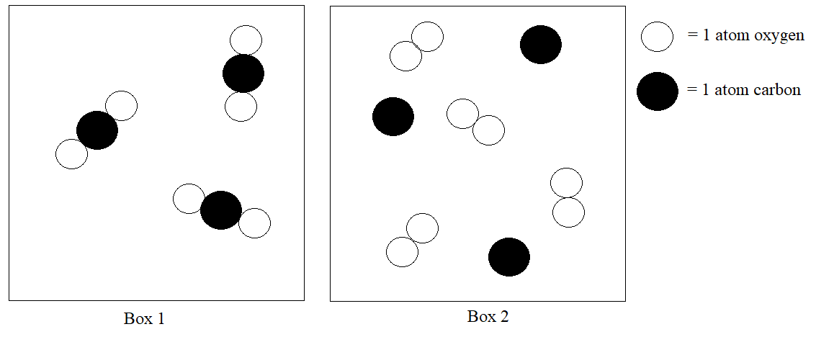

Both box 1 and box 2 contain…

* 1. at least one substance which is considered to be a molecule.
  2. at least one substance which is considered to be a compound.
  3. at least one substance which is considered to be an element.
  4. substances in the solid phase
  5. mixtures.

1. Consider the ionic compound with formula CoS. A potential name for this compound is shown below. Is this name correct? Choose the correct answer *and* explanation.

|  |  |
| --- | --- |
| **Compound** | **Possible Name** |
| CoS | cobalt(II) sulfide |

1. *No:* The compound should be named cobalt(I) sulfide because the (I) shows that one cobalt ion is present in the compound.
2. *No:* Cobalt only has one possible charge so Roman numerals are not needed in the name.
3. *No:* The sulfur ion should be named sulfate instead of sulfide.
4. *Yes:* For one cobalt ion and one sulfur ion to balance, the charge of cobalt must be +2.
5. *Yes:* The only way that cobalt and sulfur can form an ionic compound is by making cobalt(II) sulfide.
6. Some of the compounds below contain polyatomic ions. How many of the compounds are named **correctly**?

|  |  |
| --- | --- |
| **Formula** | **Name** |
| (NH4)3N | Ammonium nitride |
| N2Br2 | Nitrogen bromide |
| FePO4 | Iron(III) phosphate |
| Ca3N2 | Calcium nitrate |

* 1. 0 (None are named correctly.)
  2. 1
  3. 2
  4. 3
  5. 4 (All four are named correctly.)

1. How many of the species shown below have four neutrons?

4He 207Pb+4 7Li+ 12C

* 1. 0 (None have four neutrons.)
  2. 1
  3. 2
  4. 3
  5. 4 (All four have four neutrons.)

1. What is the mass of 0.250 moles sodium oxide?
   1. 5.75 g
   2. 9.75 g
   3. 15.5 g
   4. 39.0 g
   5. 62.0 g
2. True or false? A 1.0 mole sample of copper and a 1.0 mole sample of argon contain the same number of atoms.
   1. *True*: A mole represents 6.022×1023 of something, so both samples contain the same number of atoms.
   2. *True*: A mole and an atom are the same thing, so both samples contain the same number of atoms.
   3. *False*: The mass of the samples are different so the number of atoms in each of the samples is different.
   4. *False*: One substance is a gas and the other substance is a solid, so their numbers of atoms are different.
   5. *False*: One substance is diatomic so it has twice the number of atoms as the other substance.
3. Calculate the total number of **atoms** in 10.0 grams of liquid water.
   1. 0.555 atoms
   2. 3.34×1023 atoms
   3. 6.68×1023 atoms
   4. 1.00×1024 atoms
   5. 1.80×1024 atoms
4. What is the mass percent of sodium in sodium sulfate?
   1. 19.3%
   2. 32.4%
   3. 36.5%
   4. 41.2%
   5. 58.9%
5. You are studying an organic compound with an empirical formula of CH2O. A sample of this compound consists of 2.65 g carbon. What is the mass of oxygen in this sample?
   1. 0.222 g
   2. 0.888 g
   3. 1.77 g
   4. 3.53 g
   5. 7.06 g
6. Recall the demonstration from lecture in which the balloon was placed in the vacuum chamber and the vacuum pump was turned on. What was true about the situation as the balloon expanded?

The temperature inside the balloon increased.

The number of moles of gas inside the balloon increased.

The pressure inside the balloon increased.

* 1. The number of moles of gas outside the balloon increased.

The pressure outside the balloon decreased.

1. Consider a helium balloon as shown in lecture. This 30.0 L balloon is at a room pressure of approximately 0.950 atm at a temperature of 25.0°C. What is the mass of helium inside the balloon?
   1. 1.17 g
   2. 3.43 g
   3. 4.67 g
   4. 13.9 g
   5. 55.6 g
2. Recall the demonstration from lecture involving the air inside of the large plastic syringe. You close the syringe with your finger while it has a volume of 12.0 mL of air inside of it at a constant room temperature and pressure of 1.0 atm. You squeeze the syringe, dropping the volume of the air to 4.50 mL. What is the new pressure in the syringe?
   1. 0.269 atm
   2. 0.375 atm
   3. 2.67 atm
   4. 3.00 atm
   5. 54.0 atm
3. According to Dalton’s Law of Partial Pressures, the sum of two individual pressures of different gases in a mixture can be added together to find the total pressure of the mixture. If we assume that the air consists of only nitrogen gas and oxygen gas which behave ideally, this means that PO2 + PN2 = Ptotal. Which is **not** an assumption we made for this to be true?
   1. The volume of each individual oxygen particle and each individual nitrogen particle is zero.
   2. The nitrogen particles and the oxygen particles aren’t attracted to one another.
   3. Each nitrogen particle exerts the same pressure as each oxygen particle.
   4. The nitrogen gas and the oxygen gas both occupy the same volume.
   5. The nitrogen particles are moving at the same average speed as the oxygen particles.

**Part 2: Free Response**

Name that substance!

A compound consists of nitrogen as well as an alkaline earth metal. The compound has a molar mass of 100.94 g/mol.

1. Give the formula of the compound. ____________________
2. Show your work for how you identified the compound.

A compound consists of only carbon and hydrogen. A 5.00 g sample of this compound contains 4.28 g carbon. The molar mass of this compound is 56.11 g/mol.

1. Identify the **molecular formula** of the compound. **_________________**
2. Show your work for how you determined the molecular formula of the compound in the space below.

You have a mixture of two diatomic gases. One of these gases consists of 2.40 moles of nitrogen gas and the other consists of 153.6 grams of an unknown diatomic gas. The partial pressure of the unknown diatomic gas is twice the partial pressure of the nitrogen gas.

1. Identify the unknown gas. **______________________**
2. Show your work for how you identified the unknown gas in the space below.

***Please go on to the next page.***

Questions 22-25 relate to a gas sample in a **rigid, sealed** container. This container holds a 4.1 mole sample of an unknown monatomic gas. It is at a pressure of 2.0 atm with a volume of 50.0 L. The gas and the container together have a mass of 7,842 g.

1. What is the temperature of the gas sample? Give your answer in units of degrees Celsius.

________________

1. The empty container has a mass of 7,500. g What is the identity of the gas in the container?

________________

1. You heat the gas within the container. When you heat the sample, do the pressure, number of moles of gas, and volume of the gas increase, decrease, or remain constant? Select an answer for each below.

* The temperature of the gas increases.
* The volume of the gas ________________.
* The pressure of the gas ________________.
* The number of moles of the gas ________________.

1. Explain your answer to the question above. Your answer should separately address volume, pressure, and the number of moles of gas present and why each decreases, increases or remains constant. Your explanation for pressure should also include an explanation of particle behavior.

*Please go on to the next page.*

You place the sample of gas in a new container. The new special container is able to adjust so that its pressure and volume always remain constant.

1. When you heat the gas sample in this special container, what must be happening to the number of moles of gas in the container? Select increase, decrease, or remain constant.

* The temperature of the gas increases.
* The volume of the gas remains constant.
* The pressure of the gas remains constant.
* The number of moles of the gas _____________.

1. Explain your answer in the space below. Be sure that your explanation includes either mathematical support and words explaining your math and/or a description of particle behavior.

**Stop! You have reached the end of the test! Nothing written after this page will be graded.**