**Uranyl Cluster Assemblies for the Separation of Uranium**

Muhammad Hamza Ansar Literature Seminar October 18th, 2022

Uranium (Z = 92) in the form its isotope 235U is used in fission nuclear reactors for generation of electricity. As of 2020, there are 442 nuclear power stations distributed across 32 countries with a cumulative capacity of 392.6 gigawatts of electrical energy.1 Uranium is also used in production of radioisotopes for medicinal purposes and for powering up secluded systems such as naval vessels.2 In 2014, the worldwide annual production of uranium was 64,000 tons, and demand for uranium is expected to be near 100,000 tons by 2040.1

Owing to the intense radioactivity of uranium fission products, the safe and efficient disposal of nuclear waste is a significant societal issue.3 The post-fuel treatment of nuclear waste involves separation of recyclable radioisotopes (such as 235U) from radioisotopes that cannot be put to further use (such as 90Sr).3 There is a need to develop more chemically selective, environmentally friendly, and economically efficient methods to separate uranium from other elements.

A new class of uranium species has recently been investigated in the context of separations: uranyl peroxide polyoxometalate clusters (UPCs). The first of these clusters was discovered in 2005.4 Since then, the library has expanded to more than 40 clusters with varying topologies and sizes.5 These clusters assemble in-situ when aqueous solutions of uranyl ions (UO22+) are treated with peroxide solution under alkaline conditions. These clusters consist of [UO2(O2)2(OH)2]4− (with two *cis*-hydroxide ligands) or [UO2(O2)3]4− units linked into polyhedral arrays through hydroxide or peroxide bridges 5.

Nyman et al. have extracted the lithium salt of [UO2(O2)(OH)]2424– (U24)and the ammonium salt of [(UO2)32(O2)40(OH)24]40– (U32)from alkaline aqueous solutions into a mixture of kerosene and hexanol with cetyltrimethylammonium bromide as a surfactant. Small angle X-ray scattering (SAXS) analysis confirmed the retention of cluster structures upon movement to the organic medium. Another important feature is that this extraction does not work for monomeric uranyl ions which elucidates the fact that the interactions between clusters and surfactants are responsible for migration of uranium into organic medium. This can possibly be due to the fact that the total charge is diffused over the whole cluster which makes it easier to transition into the organic layer. For U32, the maximum distribution ratio (D = 21,000) was achieved at surfactant to cluster ratio of 15:1 and for U24 (D = 135), was achieved around 22:1. Distribution ratio is defined to be the ratio of concentration of uranium in organic medium to that of in aqueous medium. Distribution ratios reported for 0.5 mol/L of phosphoric acid based extractants for 0.34 g/L of U(VI) lie in range of 25-45.2 The reported synthesis and extraction protocol was also tested on SIMFUEL. SIMFUEL comprises of representative mixture of uranium and other fission products which can be used to simulate the behavior of post fission nuclear fuel. More than 90% of the uranium could be extracted in the form of the U32 cluster with less than 0.4% of Ba, Cs, Zr and rare earth metals (Figure 1).3

**Figure 1**. Composition analysis of aqueous solution, black precipitates and organic layer after extraction

Burns and co-workers investigated the separation of UPCs (U24, U28, U32) by membrane-based ultrafiltration methods. Three membranes with molecular mass cutoffs of 3, 8 and 20 kDa gave sieving coefficients of 0.05, 0.15 and 0.37, respectively (the sieving coefficient is the ratio of uranium concentration in the permeate to the uranium concentration in the feed solution). Uranyl nitrate hexahydrate solution was used as control to establish if monomeric uranyl ions can be separated via ultrafiltration without cluster formation. Uranyl ions were able to pass through the membranes due to their small sizes, thus, elucidating the role of UPCs in separation of uranium via ultrafiltration.6

Mei et al. reported the extraction of self-assembled uranyl-polyphenolic clusters synthesized by treating aqueous uranyl ions with C-alkylpyrogallol[4]arenes, which are polyhydroxylated macrocycles. The macrocycles are abbreviated PgC*n*, where *n* is the length of the alkyl side chains on the bridging methylene units (Figure 2B). The structure of U-PgC3 (Figure 2A) crystal structure indicates that the primary building unit is [(UO2)24(H2O)24(PgCn)6]. The extraction efficiency depends on the protonation state of the macrocycle: U-PgC9 clusters were extracted from aqueous layer into 1,2-dichloroethane and dichloromethane with distribution ratios of 300 at pH = 6.0 but ratios close to zero low concentration of NaOAc.7

 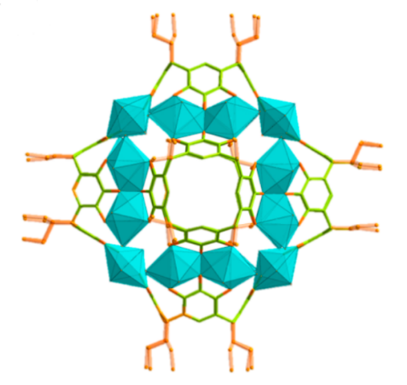

A

B

**Figure 2(A)**. Structure of U_PgC9 (**B)** Structure of PgC9

In conclusion, uranyl cluster assemblies can be used for processing of uranium during production and post-fuel treatment. These cluster assemblies can be easily prepared from aqueous solution and can be separated with exceptional distribution ratios via extraction or ultrafiltration.

**References.**

1. *IAEA Annual Report for 2020*; International Atomic Energy Agency 2020.

2. Beltrami, D.; Cote, G.; Mokhtari, H.; Courtaud, B.; Moyer, B. A.; Chagnes, A., Recovery of Uranium from Wet Phosphoric Acid by Solvent Extraction Processes. *Chemical Reviews* **2014,** *114* (24), 12002-12023.

3. Neal, H. A.; Szymanowski, J.; Fein, J. B.; Burns, P. C.; Nyman, M., Benchmarking Uranyl Peroxide Capsule Chemistry in Organic Media. *European Journal of Inoraganc Chemistry* **2017,** *2017* (1), 39-46.

4. Burns, P. C.; Kubatko, K.-A.; Sigmon, G.; Fryer, B. J.; Gagnon, J. E.; Antonio, M. R.; Soderholm, L., Actinyl Peroxide Nanospheres. **2005,** *44* (14), 2135-2139.

5. Burns, P. C.; Nyman, M., Captivation with encapsulation: a dozen years of exploring uranyl peroxide capsules. *Dalton Transactions* **2018,** *47* (17), 5916-5927.

6. Wylie, E. M.; Peruski, K. M.; Weidman, J. L.; Phillip, W. A.; Burns, P. C., Ultrafiltration of Uranyl Peroxide Nanoclusters for the Separation of Uranium from Aqueous Solution. *ACS applied materials & interfaces* **2014,** *6* (1), 473-479.

7. Mei, L.; Ren, P.; Wu, Q.-y.; Ke, Y.-b.; Geng, J.-s.; Liu, K.; Xing, X.-q.; Huang, Z.-w.; Hu, K.-q.; Liu, Y.-l.; Yuan, L.-y.; Mo, G.; Wu, Z.-h.; Gibson, J. K.; Chai, Z.-f.; Shi, W.-q., Actinide Separation Inspired by Self-Assembled Metal–Polyphenolic Nanocages. *Journal of the American Chemical Society* **2020,** *142* (39), 16538-16545.