##### CHEMISTRY 101 Name ______________ ____________________

Hour Exam III

December 1, 2022 Signature ________________________________

McCarren

#### Section ______________________________________

***“The most important thing is this: to sacrifice what you are now for what you can become tomorrow.”*** *―****Shannon Alder***

This exam contains 25 questions. The first 15 questions are multiple choice, and the remaining questions are all drop down questions. Please be sure to answer all questions before submitting the exam. A periodic table is attached to this equation sheet and you may also use it as scratch paper.

Useful information:

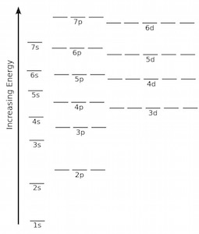

**Part 1: Multiple Choice**

1. Which of the following processes are exothermic? The system is underlined in each case.
2. A **ball** hardening in liquid nitrogen
3. **Water** boiling when cooking pasta
4. **Ice** melting in a glass of water
5. **Natural gas** burning in a Bunsen burner
   1. I only
   2. III only
   3. I and IV
   4. II and III
   5. II and IV
6. 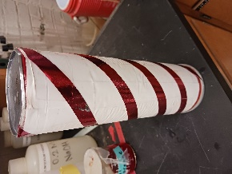Recall the demonstration in lecture when the pringles can was filled with hydrogen and oxygen gas, ignited, and went “boom.” You are discussing process this with your friend and they say, “This was an endothermic process overall. Endothermic processes need heat, and in this case lighting the match added heat which made this reaction endothermic.” Should you agree with your friend?
   1. *Yes*: The addition of the flame added the energy required to make this an endothermic process.
   2. *No:* Endothermic processes release heat instead of require heat, so this process was exothermic because it required heat.
   3. *No:* This reaction did require heat to get started, but much more heat was released, making it exothermic overall.
   4. *No:* This was an endothermic process, but lighting the match was not what made it endothermic overall.
   5. *No:* Though the match helped the reaction occur, this was an endothermic process overall because heat was added to the system when the hydrogen and oxygen reacted.
7. Which of the following is **false** regarding our current understanding of the atom?
   1. Electrons orbit the outer edges of each atom in clearly defined routes.
   2. There is a small positively charged center of each atom.
   3. The outer electrons of an atom may interact with other electrons to form bonds between atoms.
   4. Atoms consist of three different types of particles: positively charged, negatively charged, and neutral.
   5. An atom is made up of mostly empty space.
8. Consider the ground state electron configuration shown below which is for a neutral atom. Each blank represents an integer. What numbers should go in these blanks? Note: the blanks can all contain the same value but do not have to.

**[Kr] ___s2___ d10___p4**

1. 5, 4, 5
2. 5, 5, 5
3. 5, 4, 4
4. 4, 4, 4
5. 4, 3, 4
6. Choose the following option which correctly ranks the neutral atoms below from least to greatest first ionization energy.
   1. O < P < Ge < Sn
   2. Ge < Sn < P < O
   3. Sn < Ge < P < O
   4. Ge < P < Sn < O
   5. O < Ge < P < Sn
7. Compare the sizes of the three **ions** shown below. Which ion is larger? Choose the correct answer *and* explanation.

Mg+2 O2-

* 1. Both are the same size: The same number of electrons are present in each so they repel each other with the same strength.
  2. *Mg+2*: It has the most electrons which are further repelled from the nucleus.
  3. *Mg+2*: It is furthest down and left on the periodic table which is where the largest atoms are.
  4. *O2-*: It has the greatest amount of negative charge.
  5. *O2-*: It has the lowest number of protons so it most weakly attracts the electrons.

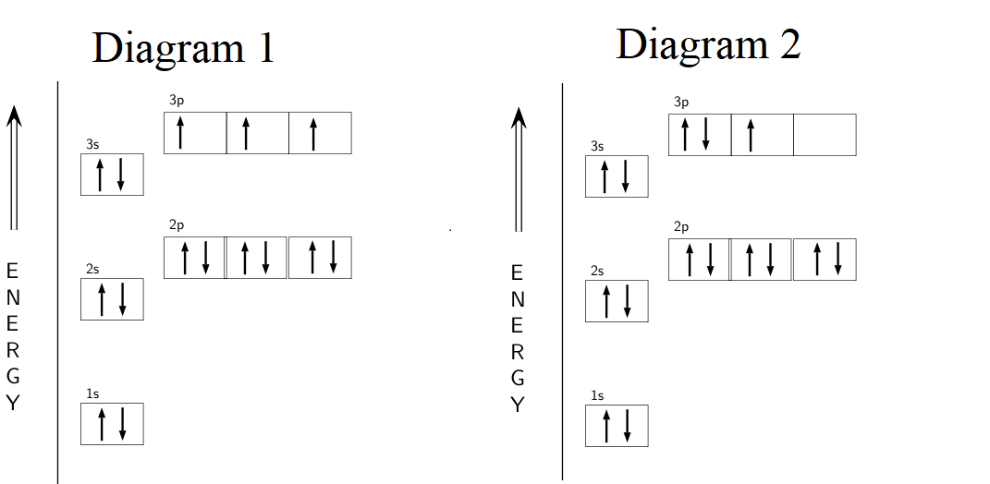

1. Consider the electron filling diagrams above which both represent possible diagrams for the same atom. These diagrams may show either ground or excited state electron arrangements. Which neutral atom do these diagrams represent?
   1. Carbon
   2. Oxygen
   3. Silicon
   4. Sulfur
   5. Phosphorus
2. Which of these diagrams is preferred for a **ground state** neutral atom? Choose the correct answer and reason?
   1. *Diagram 1:* This option minimizes interactions of electrons in orbitals.
   2. *Diagram 1:* This option maximizes the number of electrons in the preferred spin up state.
   3. *Diagram 2:* This option demonstrates that it is required that each orbital be filled completely before moving to the next.
   4. *Diagram 2:* This option maximizes the number of orbitals that are full.
   5. *Either diagram 1 or diagram 2:* As long as the correct number of electrons are present, both configurations are equally preferred.
3. What is the purpose of a covalent bond?

***A covalent bond connects…***

* 1. a metal and a nonmetal atom within the same molecule.
  2. two non-metal atoms within the same molecule.
  3. two separate molecules of the same substance.
  4. two electrons that are in the same orbital.
  5. two metal atoms within the same molecule.

Consider the three compounds with formulas shown below. Draw Lewis structures for each of these and use them to answer the questions.

|  |  |  |  |
| --- | --- | --- | --- |
| **Compound** | **I** | **II** | **III** |
| Formula | CH3OCH3 | CH3OH | C2H4 |

1. Consider the carbon atoms in each molecule. For which molecules is there a tetrahedral shape around at least one carbon atom within the molecule?
   1. I only
   2. II only
   3. III only
   4. I and II
   5. I, II, and III
2. For which molecule(s) is there a net dipole moment?
   1. I is the only polar molecule
   2. II is the only polar molecule.
   3. III is the only polar molecule.
   4. I and II are both polar.
   5. I, II, and III are all polar.
3. Which can display hydrogen bonding forces?
   1. I only
   2. II only
   3. III only
   4. I and II
   5. I, II, and III
4. The Lewis structure for the molecule CO is shown below. What is one of the limitations of using this Lewis structure to represent the molecule?

What is the Lewis dot structure for carbon monoxide? | Socratic

* 1. The Lewis structure shows ten valence electrons which is not the correct number.
  2. The Lewis structure shows the electrons as distributed evenly between the carbon and oxygen but they are not.
  3. The Lewis structure should show the intermolecular forces present, but it does not.
  4. The Lewis structure shows the bond between carbon and oxygen as a triple bond but the real bond is actually a double bond.
  5. The Lewis structure shows that the molecule has a linear shape but it is actually a bent/v-shape substance.

1. Which of the following diatomic molecules has the **highest** boiling point?
   1. Cl2
   2. H2
   3. F2
   4. HBr
   5. HF
2. Which of the following molecules has the **lowest** boiling point?
   1. Cl2
   2. H2
   3. F2
   4. HBr
   5. HF

**Part 2: Free Response**

**Section A**

Name that element!

Each of the following clues below represents an element between #1 and #50 on the periodic table. Select the correct element based on the clue.

|  |  |  |
| --- | --- | --- |
|  | **Clue** | **Element** |
| 16 | This neutral element has a ground state electron configuration of [Kr]5s24d8. |  |
| 17 | This element is the smallest halogen. |  |
| 18 | This element has a total of 12 electrons in the fourth energy level (n = 4) overall. |  |
| 19 | This element is the largest element in its period on the periodic table. It is also the smallest element in its group.  (Note: period = horizontal row, group = vertical column) |  |
| 20 | This noble gas has the weakest London dispersion forces of all noble gases. |  |
| 21 | This third-row element “X” is the central atom of the XCl4 see-saw shaped molecule. |  |

**Section B**

For the next four questions, draw Lewis structures for the molecules in each set and use them to fill out each table.

1. The following three molecules each have the **same electron pair geometry**. Draw Lewis structures for each molecule in the set and use those Lewis structures to give the electron pair geometry, molecular shape, and polarity around each central atom.

|  |  |  |  |  |
| --- | --- | --- | --- | --- |
| **Molecule** | **Electron Pair Geometry** | **Molecular Shape** | **Bond Angles** | **Polar?** |
| CH2O |  |  |  |  |
| BH3 |  |  |  |  |
| SO2 |  |  |  |  |

1. The following three molecules each have the **same electron pair geometry**. Draw Lewis structures for each molecule in the set and use those Lewis structures to give the electron pair geometry, molecular shape, and polarity around each central atom.

|  |  |  |  |  |
| --- | --- | --- | --- | --- |
| **Molecule** | **Electron Pair Geometry** | **Molecular Shape** | **Bond Angles** | **Polar?** |
| SF4 |  |  |  |  |
| ClBr3 |  |  |  |  |
| ArCl2 |  |  |  |  |

1. The following three molecules each have the **same electron pair geometry**. Draw Lewis structures for each molecule in the set and use those Lewis structures to give the electron pair geometry, molecular shape, and polarity around each central atom.

|  |  |  |  |  |
| --- | --- | --- | --- | --- |
| **Molecule** | **Electron Pair Geometry** | **Molecular Shape** | **Bond Angles** | **Polar?** |
| PH3 |  |  |  |  |
| CH4 |  |  |  |  |
| CH2Cl2 |  |  |  |  |

1. The following three molecules each have the **same electron pair geometry**. Draw Lewis structures for each molecule in the set and use those Lewis structures to give the electron pair geometry, molecular shape, and polarity around each central atom.

|  |  |  |  |  |
| --- | --- | --- | --- | --- |
| **Molecule** | **Electron Pair Geometry** | **Molecular Shape** | **Bond Angles** | **Polar?** |
| XeCl4 |  |  |  |  |
| SCl6 |  |  |  |  |
| ICl5 |  |  |  |  |