Incorporating Nanomaterials into Masks to Better Protect against COVID-19

Autumn Cook Literature Seminar November 17, 2022
As of November 2022, COVID-19 is still a health threat on a global scale.¹ Despite the rapid invention and distribution of vaccines and post-infection treatments that have helped mitigate the impact of the virus, the amount of deaths COVID-19 has caused is staggering. According to the Center for Disease Control and Prevention (CDC) approximately 2,500 people still die of COVID-19 each week to with the total death count in the US approaching 1.1 million total deaths.² SARS-CoV-2, the virus that causes COVID-19, is in the family of highly infectious coronaviridae viruses that include Middle East respiratory syndrome (MERS) and severe acute respiratory syndrome (SARS). Despite the relation to other well-known coronaviruses, the long-term health implications of COVID-19 infections are still unclear.¹
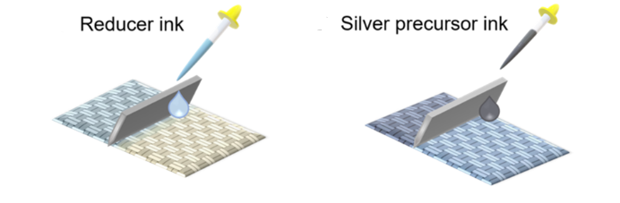
Masking is the second-best way to prevent the spread of COVID-19 following social isolation.³ There are many types of masks on the market, including cloth masks, medical grade surgical masks, N95 respirators and more. Although both cloth masks and surgical masks are slightly effective in preventing the spread of viruses, N95 respirators offer better protection for a relatively low monetary cost. When compared to not wearing a mask at all, a person is 56% less likely to catch COVID-19 if they wear a cloth mask, 66% less likely if they wear a surgical mask, and 83% less likely if they wear a N95 respirator.³ Because of their higher level of protection, N95 respirators were recommended for U.S. medical personnel involved in treating COVID-19 patients.⁴
N95 masks are a relatively recent innovation, they were developed and patented in 1995 by Peter Tsai from the Department of Material Science and Engineering at the University of Tennessee.⁵ N95 masks are made of multiple layers of melt-blown polypropylene fibers, which serve as both a mechanical barrier to prevent aerosols from entering the respiratory track and a Coulombic barrier as the fibers carry small charges.⁶ Although N95 masks are effective in trapping the COVID-19 virus, they cannot inactivate viruses, which makes it possible for contaminated masks to shed virus and cause new infections.⁴ Polypropylene has no inherent anti-viral activity, but certain metals, such as zinc, copper, and silver do. These metals have the potential to disrupt a virus’s phospholipid bilayer, destroying the genetic material stored within and inactivating the virus entirely.⁷
Figure 1. The reactive blade coating process. ⁸
To create better masking technology that actively inactivates virus particles and further combat the COVID-19 pandemic, researchers have begun to incorporate metal nanoparticles into existing mask technologies to produce a mask that is more effective in protecting against COVID-19. In 2021, Abulikemu et al. coated a polypropene mask in with silver nanoparticles and measured the mask’s resulting antimicrobial properties. Thin layers of both oleylamine reducing ink and silver precursor solution (AgNO₃) were deposited on the surface of the mask by a reactive blade coating process (Fig. 1). After a heat treatment, silver nanoparticles were deposited on the mask as shown by SEM imaging.
Swatches of this material were subsequently exposed to aliquots of a viral load solution containing a SARs-CoV-2 analog, HCoV-229E. After a pre-determined exposure time, the mask swatches were washed with viral recovery solution to collect the remaining virus. Cells were exposed to this virus solution and then were incubated and cultured; the amount of viral activity was compared to a control. Abulikemu et al. determined that a 30-minute exposure of the virus to the mask coated with silver nanoparticles significantly decreased the infectivity of the virus by about a factor of 2, as measured by plaque forming units per milliliter (PFU/mL). Shorter exposure times of 1 and 10 minutes were far less effective in inactivating the virus.⁸
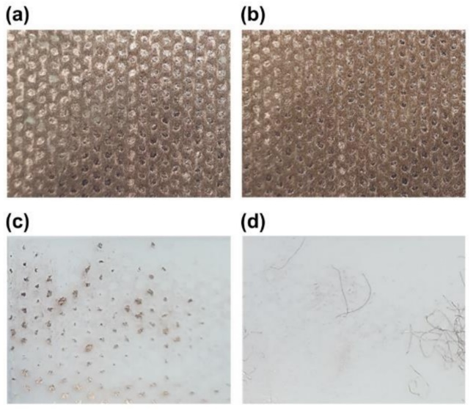
In April 2021, Jung et al. investigated commercially available KF94 (Korea’s equivalent to an N95) masks coated with a copper thin film were effective in inactivating the COVID-19 virus. To increase the adhesion of the copper to the polypropylene fibers of the mask, the authors first exposed the mask to an oxygen ion beam and then coated the fibers with copper through direct current magnetron sputtering. It was expected that the oxygen ions should increase adhesion by reacting with the polypropylene and causing the formation of a metal oxide interlayer (Fig. 2a, 2b). The adhesion of the copper film to the mask was tested by using Scotch® tape to try to peel off the copper film. For an untreated mask, a significant amount of copper stuck to the tape (Fig. 2c), whereas when it was applied to a treated mask, only a few copper-coated mask filaments were removed, demonstrating that the oxygen treatment did increase the adhesion of the copper. (Fig. 2d).
To test the antiviral properties of the copper-coated mask, a viral solution was added to a mask swatch and left to incubate for one hour. After incubation, the virus was recovered from the mask and transferred into Vero cells which were cultured for 48 hours. A polymerase chain reaction (PCR) assay was carried out to amplify selected gene sequences to determine whether the SARs-CoV-2 was still active after the contact with the mask. It was determined that no virus survived contact with the copper-coated mask. This reduction in viral activity was confirmed by means of an immunochemical fluorescence assay, which showed a 75% reduction in RNA replication.⁹
Figure 2. Tape adhesion testing with
(a) non-oxygen treated copper coated mask
(b) oxygen treated copper coated mask
(c) tape surface of non-oxygen treated mask
(d) tape surface of oxygen treated mask
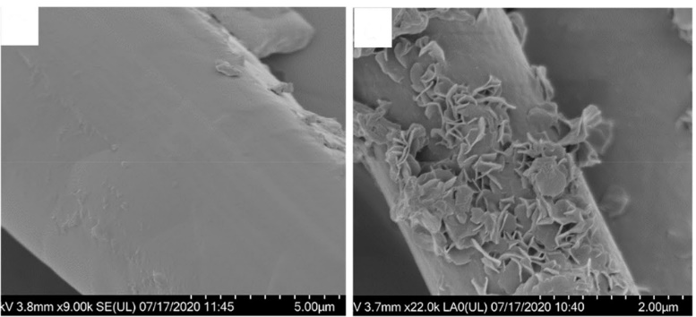
In December 2021, Gonzales et al. studied the anti-viral properties of a polypropylene mask containing embedded zinc oxide nanoparticles. The mask sample was immersed in a solution of zinc acetate, the solution was removed, and the solution saturated mask was heated to induce nucleation and growth of zinc oxide nanoparticles on the polypropylene filaments (Fig. 3). A longevity test showed that the zinc oxide nanoparticles were well adhered: there was no impact on the nanoparticle loading after 100 wash cycles.
Figure 3. SEM images of (a) an untreated polypropylene filament and (b) a zinc oxide treated polypropylene filament
a
b
To test the antiviral properties of the nanoparticle impregnated mask, TGEV, a SARS-CoV-2 analog, was placed onto the mask 10, 30, or 60 minutes. TCID₅₀ titration analyses showed that the amount of active virus decreased by 99.9% after being in contact with the zinc oxide nanoparticle treated mask for 10 minutes and by >99.9% after longer times. This finding was corroborated by the PCR analyses, which indicated that the number of virus genome copies had been reduced by >90%. This discrepancy is likely due to the ability of PCR to detect inactive but intact RNA resulting from the nanoparticle-induced dissolution of the virus capsid without destroying the genomic material.^{10,11}
Although all three papers demonstrated incorporation of nanomaterials resulted in masks that showed the ability to deactivate the COVID-19 virus further experimentation must be done to assess both the acute and chronic health risk associated with breathing in metal or metal oxide nanoparticles. FDA approval would have to be obtained before any of these treated masks could be marketed and used by the public. If this obstacle can be overcome, however, nanoparticle-decorated masks and filtration technology could become a powerful tool to protect against COVID-19 and other similar viruses that pose a significant risk to public health.

References:
- Bowe, B.; Xie, Y.; Al-Aly, Z. Acute and Postacute Sequelae Associated with SARS-CoV-2 Reinfection. Nat Med 2022, 1–8. https://doi.org/10.1038/s41591-022-02051-3.
- CDC Covid Data Tracker, https://covid.cdc.gov/covid-data-tracker/#datatracker-home
- Andrejko, K. L. Effectiveness of Face Mask or Respirator Use in Indoor Public Settings for Prevention of SARS-CoV-2 Infection — California, February–December 2021. MMWR Morb Mortal Wkly Rep 2022, 71. https://doi.org/10.15585/mmwr.mm7106e1.
- Rashid, T. U.; Sharmeen, S.; Biswas, S. Effectiveness of N95 Masks against SARS-CoV-2: Performance Efficiency, Concerns, and Future Directions. ACS Chem. Health Saf. 2022, 29 (2), 135–164. https://doi.org/10.1021/acs.chas.1c00016.
- Tsai, P.; Wadsworth, L. Enhancement of barrier fabrics with breathable films and of face masks and filters with novel fluorochemical electret reinforcing treatment. U.S. Patent US20050079379A1, April 14, 2005.
- Bandi, M. M. Electrocharged Facepiece Respirator Fabrics Using Common Materials. Proceedings of the Royal Society A: Mathematical, Physical and Engineering Sciences 2020, 476 (2243), 20200469. https://doi.org/10.1098/rspa.2020.0469.
- Bar, G.; Biswas, D.; Pati, S.; Chaudhary, K.; Bar, M. Anti Viral Finishing on Textiles - An Overview. Textile & Leather Review 2021, 4, 5–22. https://doi.org/10.31881/TLR.2020.17.
- Abulikemu, M.; Tabrizi, B. E. A.; Ghobadloo, S. M.; Mofarah, H. M.; Jabbour, G. E. Silver Nanoparticle-Decorated Personal Protective Equipment for Inhibiting Human Coronavirus Infectivity. ACS Appl Nano Mater 2021, acsanm.1c03033. https://doi.org/10.1021/acsanm.1c03033.
- Jung, S.; Yang, J.-Y.; Byeon, E.-Y.; Kim, D.-G.; Lee, D.-G.; Ryoo, S.; Lee, S.; Shin, C.-W.; Jang, H. W.; Kim, H. J.; Lee, S. Copper-Coated Polypropylene Filter Face Mask with SARS-CoV-2 Antiviral Ability. Polymers (Basel) 2021, 13 (9), 1367. https://doi.org/10.3390/polym13091367.
- Gonzalez, A.; Aboubakr, H. A.; Brockgreitens, J.; Hao, W.; Wang, Y.; Goyal, S. M.; Abbas, A. Durable Nanocomposite Face Masks with High Particulate Filtration and Rapid Inactivation of Coronaviruses. Sci Rep 2021, 11 (1), 24318. https://doi.org/10.1038/s41598-021-03771-1.
- Novi, V. T.; Gonzalez, A.; Brockgreitens, J.; Abbas, A. Highly Efficient and Durable Antimicrobial Nanocomposite Textiles. Sci Rep 2022, 12 (1), 17332. https://doi.org/10.1038/s41598-022-22370-2.

