**Twist as a Variable to Tune Interfacial Chemistry of 2D Materials: The Quest for the Magic Angle**

Seth T. Putnam Literature Seminar November 17, 2022

Two-dimensional materials are ordered solids with a thickness of one atomic unit. A wide variety of compositions can form single-layer materials, of which the most widely investigated is graphene, which consists of a hexagonal lattice of sp2bonded carbon atoms.1 2D materials display a variety of interesting properties stemming from the confinement of electrons to a single plane. A recent focus in the study of these unique materials has been the tuning their electronic and physical properties. For example, modifications of their physical properties can be achieved by the controlled introduction of lattice vacancies or heteroatoms.2 However, such chemical modifications can be difficult to achieve selectively and reproducibly due to the often-challenging synthetic conditions required. In this presentation, I will introduce a new approach to modulate the physical and chemical properties of 2D materials by creating a relative twist angle between monolayers.

Moiré patterns are interference patterns that can be created by overlapping identical periodic templates with a rotational offset. These patterns possess a periodicity that is unique from the constituent layers but depends on the original templates and the relative twist angle between them. Moiré patterns involving twisted graphite layers (**Figure 1a**) were first observed in 1990 by scanning tunneling microscopy (STM).4 It was later shown that these moiré patterns did not originate from physical buckling of the graphene layers, but instead to a local modulation in the tunneling current.5 This finding raises the question why the relative twist between graphene sheets affects the electronic properties of the whole ensemble.



**Figure 1. (a)** Moiré pattern of graphene bilayers twisted by 4 degrees. Wikimedia Commons.3 **(b)** Electronic band structure of monolayer graphene as depicted in reciprocal space. Wikimedia Commons.6

In monolayer graphene, the conduction and valence bands meet at six specific points within the first Brillouin zone (**Figure 1b**). As a result, graphene is often described as a semi-metal. The points where the conduction and valence bands meet are called the K-points, and the conical surfaces of the Brillouin zone on either side of the meeting points are called Dirac cones.

In 2011, Bistritzer and MacDonald proposed that at specific small “magic angles” of twisting between two graphene layers the Dirac cones would overlap and lead to flat electronic bands near zero energy with a high density of states as shown in **Figure 2**.8 They proposed that such a structure could exhibit superconductivity or other exceptional electronic properties. In 2018, Cao et al. confirmed that, near the predicted 1.1° magic twist angle, graphene bilayers display superconductivity at temperatures below 1.7 K.9 The superconductive behavior was considered unconven­tional because it cannot be explained by traditional Bardeen-Cooper-Schrieffer theory. The source of this unconventional superconductivity remains an unresolved question in the field of condensed matter physis.

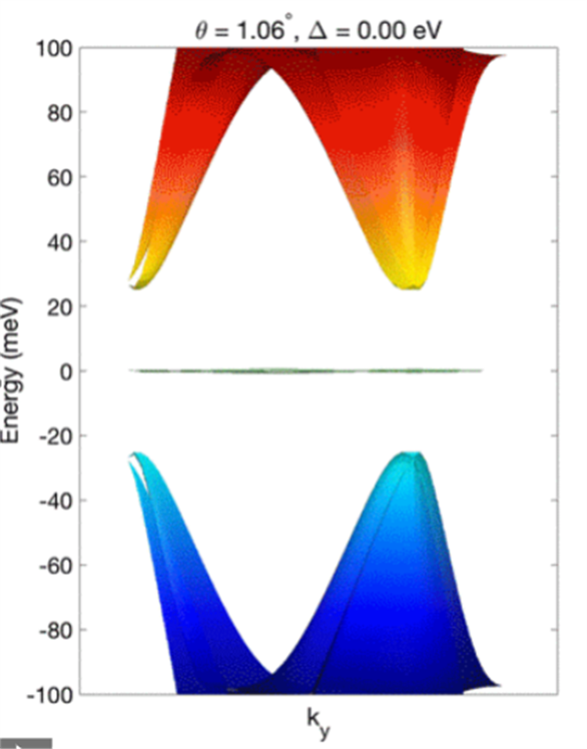

**Figure 2.** Predicted electronic band structure of magic angle twisted graphene bilayers. The presence of a flat band near zero energy is indicative of exceptional conductivity and other electronic properties.7

The selective modulation of the electronic band structure created by twisting also allows for the selective enhancement of certain chemical properties leading to enhanced reactivity in a variety of applications. I will highlight three articles that show how the twisting of bilayers of graphene and transition metal dichalcogenides can modulate the catalytic, photochemical, and electro­chemical behavior of these 2D materials.10,11,12

The first application involves the tuning of the photochemical reactivity of graphene bilayers.10 In this study, the authors synthesized bilayer graphene with a variety of twist angles between 0 to 30°. They characterized these twist angles by transmission electron microscopy (TEM) and selected area electron diffraction (SEAD). Interestingly, at specific twist angles there is a significant enhancement of the graphitic G-peak in the Raman spectrum. When the excitation laser wavelength was changed, the enhancement occurred at a different twist angle (**Figure 3**). The authors proposed that this signal enhancement was due to resonance between the laser energy and the band gap created from the Dirac cone overlap (**Figure 3 inset)**.



**Figure 3.** Plot of Raman signal intensity as a function of twist angle on graphene bilayers at three different wavelengths. The inset shows the angle dependent energy gap created by the overlapping Dirac cones.

To investigate whether this photo­physical behavior could be used to control photochemical reactivity, the authors coated the twisted graphene bilayers with a dilute solution of benzoyl peroxide. If optical stimulation of the graphene bilayer results in ejection of electrons, the benzoyl peroxide will split into phenyl radicals that will bond to the graphene surface, converting the sp2 carbons to sp3. The modification of the graphene surface can be monitored by changes in the D-band peak in the Raman spectrum of graphene that is associated with disorder. The researchers found that, at the twist angles at which the Raman signal is enhanced, the photochemical reaction proceeds significantly faster. At the resonant, or magic angles, the reaction could be completed in ~10 seconds, compared to many minutes for the non-resonant substrates.

In a similar experimental scheme, the authors compared the relative rates of a radical reaction on twisted vs. pristine graphene bilayers.11 Aryldiazonium salts were selected that, when reduced, form aryl radicals that can react with the graphene surface. Similarly, the extent of reaction can be monitored by the graphene D-band in the Raman spectrum. The authors found that the reaction on the twisted bilayer graphene proceeded at a rate ~3 times faster than on the pristine sample. Unfortunately, only a single, relatively large twist angle (~25 degrees) was investigated, which does not allow for the quantitative understanding of how the twist angle affects the reaction rates, particularly closer to the superconducting magic angle. However, in 2022, the Bediako group quantitatively measured outer sphere electrochemical rate constants as a function of twist angle.13 They found a ~10-fold enhancement in the electron transfer rate constant near the magic angle compared to a pristine bilayer.

Although graphene is the most studied 2D material, the concept of using twist angle to modulate reactivity is not unique to that specific material. In 2019, Jiang et al, investigated the effect of twisting on the catalytic activity of MoS2 bilayers for the hydrogen evolution reaction (HER).12 The authors first synthesized a twisted MoS2 bilayer by epitaxy, and then exfoliated the bilayers to induce a twist in what they termed nanoscrolls (**Figure 4**). The bilayers in the nanoscrolls are twisted by ~7.3° and form a clear moiré pattern that is visible by TEM. The researchers demonstrated that the strained MoS2 in the nanoscroll did not undergo a phase transition from the pristine bilayer. The authors then investigated the catalytic activity of the twisted MoS2 by microfabricating a small electrochemical cell around the material of interest and filling it with 0.5 M sulfuric acid. Under these acidic conditions, HER can be performed by reducing protons to H2 gas. Contact was made with the MoS2 by a glassy carbon nanoprobe. Compared to the pristine MoS2 bilayer, the twisted MoS2 bilayer showed a 50% reduction in the overpotential necessary to initiate the electrocatalytic reaction. Unfortunately, the researchers were unable to investigate the effects of twist angle quantitatively due to the limitations of their synthetic method.

**Figure 4.** Schematic depiction of the synthesis of a MoS2 nanoscroll. The rolling up of the bilayer induces the twist angle strain.

The study of effect of twist angle on 2D materials is hampered by a lack of simple, high throughput synthetic methods. Currently, most materials must be synthesized and manually exfoliated and rotated to obtain a variety of specific, quantitative twist angles. However, two recent studies have shown that twisted graphene can be grown by chemical vapor deposition.14,15 The first method involves nucleation of graphene monolayer growth at two different sites on a copper surface to induce the formation of twisted bilayers. The second method involves growing graphene between two tightly spaced copper foils held at the desired twist angle. In the future, the increased availability of samples should accelerate study in this field. Increasing interest should also be paid to studies of twisted bilayers of transition metal dichalcogenides and other non-metallic 2D materials. Finally, although the characterization and physical properties of these materials is of great interest, there has been little work on exploring their chemical properties. This promising area of research will likely yield a variety of fundamental advances in our understanding of structure-activity relationships as well as practical materials with exceptional chemical properties.

**References**

1. Yu, W., Gong, K., Li, Y., Ding, B., Li, L., Xu, Y., Wang, R., Li, L., Zhang, G., Lin, S. *Small* **2022,** 18, 2105383.
2. Yu, Q., Luo, Y., Mahmood, A., Liu, B., Cheng, H-C. *Electrochem. Energy Rev.,* **2019,** 2, 373-394.
3. https://commons.wikimedia.org/wiki/File:Moire_of_twisted_bilayer_graphene.svg Accessed 10/25.22.
4. Kuwabara, M., Clarke, D.R., Smith, D.A. *Appl. Phys. Lett.* ***1990,*** *56, 2396.*
5. Rong, Z.Y., Kuiper, P. *Phys. Rev. B.* **1993,** 48, 23, 17427-17431.
6. https://commons.wikimedia.org/wiki/File:Electronic_band_structure_of_graphene.svg Accessed 10/25/22.
7. B. Chittari, University of Seoul, South Korea as reported in https://als.lbl.gov/the-flat-band-in-magic-angle-graphene-visualized/
8. Bistritzer, R., MacDonald, A.H. *Proc. Natl. Acad. Sci. U.S.A.* **2011,** 108, 30, 12233-12237.
9. Cao, Y., Fatemi, V., Fang, S., Watanabe, K., Taniguchi, T., Kaxiras, E., Jarillo-Herrero, P. *Nature* **2018,** 556, 43-50.
10. Liao, L., Wang, H., Peng, H., Yin, J., Koh, A.L., Chen, Y., Xie, Q., Peng, H., Liu, Z. *Nano Lett.* **2015,** 15, 5585-5589.
11. Ding, Y., Peng, Q., Gan, L., Wu, R., Ou, X., Zhang, Q., Luo, Z. *Chem. Mater.* **2016,** 28, 1034-1039.
12. Jiang, Z., Zhou, W., Hong, A., Guo, M., Luo, X., Yuan, C. *ACS Energy Lett.* **2019,** 4, 12, 2830-2835.
13. Yu, Y., Zhang, K., Parks, H., Babar, M., Carr, S., Craig, I.M., Van Winkle, M., Lyssenko, A., Taniguchi, T., Watanabe, K., Viswanathan, V., Bediako, D.K. *Nature Chem.* **2022,** 14, 267-273.
14. Sun, L., Wang, Z., Wang, Y., Zhao, L., Li, Y., Chen, B., Huang, S., Zhang, S., Wang, W., Pei, D., Fang, H., Zhong, S., Liu, H., Zhang, J., Tong, L., Chen, Y., Li, Z., Rummeli, M.H., Novoselov, K.S., Peng, H., Lin, L., Liu, Z. *Nature Comm*. **2021**, 12, 2391.
15. Liao, M., Wei, Z., Du, L., Wang, Q., Tang, J., Yu, H., Wu, F., Zhao, J., Xu, X., Han, B., Liu, K., Gao, P., Polar, T., Sun, Z., Shi, S., Yang, R., Zhang, G. *Nature Comm.* **2020**, 11, 2153.