First Steps Toward Triboelectric Nanogenerators as Mechanical Energy Harvesting Systems
Akilah Miller Literature Seminar 1 December 2022

Portable devices such as cell phones are convenient ways to access information, entertainment, and communication on the go. Their convenience is limited, however, by the necessity to charge their batteries regularly with power from an electrical grid connected to traditional stationary power sources. Portable solar cells can be used to recharge cell phones, but their power output is much less than the 5 W that typical smart phones need.
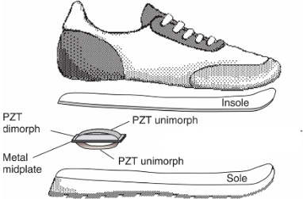
Figure 1. Piezoelectric device as a heel insert. Reproduced from reference 3.
An alternative kind of portable energy source makes use of everyday mechanical movement. For example, a 80 kg person walking at 2 steps/s generates around 67 W of power.^{1, 2} One question is whether enough of this power can be captured to charge a cell phone. In one design, conventional piezoelectric transducers were placed inside the heels of shoes; unfortunately, however, the maximum reported power capture was only 42 mW, of which only 8.4 mW could be converted to electrical power (Figure 1).³
Newer energy harvesting technologies known as triboelectric nanogenerators (TENGs) have much higher energy conversion efficiencies than conventional piezoelectric devices: as high as 85%.⁴ As a result, there is interest in using TENGs to harvest and convert ambient mechanical energy, such as walking, into electrical energy.⁵
The triboelectric effect (TE) is a type of contact electrification in which materials become electrically charged upon contact with a different material; the phenomenon occurs at interfaces between nearly all material types.⁶ The triboelectric effect arises from a combination of friction and contact electrification. Here, we will discuss only TE generated at solid-solid interfaces between metals and dielectrics and between two dielectrics.
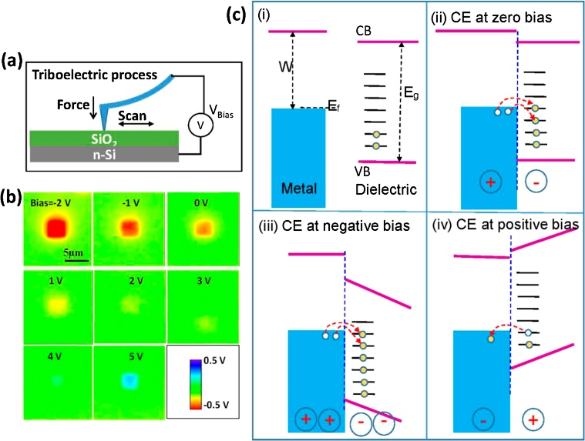
Figure 2. (a) AFM apparatus (b) KPFM images of surface potential for SiO₂ (c) mechanism of charge excitation (CE) under zero, negative and positive voltage biases. Reproduced from reference 7.

Contact electrification (CE) across a solid-solid interface is thought to be the result of mechanically induced electron cloud overlap, allowing for a transfer of electrons between the two materials.⁴ Zhou et al. visualized CE of a SiO₂ sample on top of n-Si with kelvin probe force microscopy (KPFM) and atomic force microscopy (AFM). A conducting AFM Pt tip with a 50 nm diameter was used to press the SiO₂ into the underlying n-Si surface, and the resulting surface potential within a 5 µm area was determined from the potential difference between the tip and the sample upon contact (Figure 2).⁷ A voltage bias was applied to nullify the contact potential difference; this voltage bias is equal to difference in work function between the sample and the tip, thus allowing the magnitude and sign of the contact potential as a result of TE to be measured.^{4, 8}
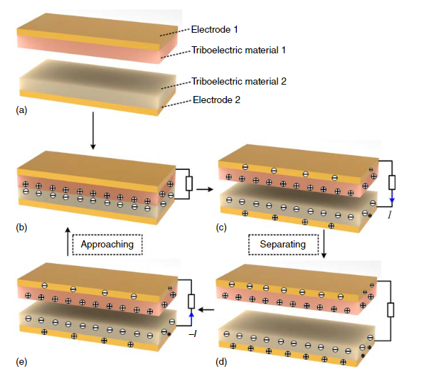
Figure 3. Schematic of a contact-mode TENG. Reproduced from reference 10.
The Wang group at Georgia tech were the first to construct a TENG device in 2012.⁹ The general design of their device is shown in Figure 3: with a mechanical stimulus triboelectric materials 1 and 2 experience friction as they come into contact (Figure 3b). Upon release from the stimulus, the insulating triboelectric materials maintain their charges as they separate, and a current is generated through the external circuit to maintain neutrality in the device (Figure 3c-d). With another mechanical stimulus, charged surfaces move back together and generate a current in the opposite direction, returning the device to its initial state, where the process can start again (Figure 3e-b).¹⁰
Kim et al. designed a TENG based on a core-shell architecture containing the following components: a core consisting of a polyurethane thread wrapped helically with a Ag-coated Cu conductive fiber, and a shell consisting of polydimethylsiloxane with an outer radius coated with Au-coated Cu conductive textile and silicone (Figure 4).¹¹ Though not clearly stated in the paper, the polyurethane acts as the more electropositive triboelectric material, the polydimethylsiloxane acts as the more electronegative triboelectric material, and the conductive fibers and textile act as the electrodes. Because of its cylindrical structure, the triboelectric effect occurs with compression, bending and twisting. When three of these structures are braided together, the core-shell TENGs displayed enhanced voltage and current responses (150 V and -15 µA) compared to a single core-shell TENG (75 V and -5 µA). When the device was placed in the insole of a shoe, the highest voltage and current responses were observed when subjected to jumping mechanical stimulus (80 V and –7 µA). Without consideration of possible load resistances, a calculated peak power of 0.56 mW is possible. At this power level, it would take nearly 2,000 devices placed in series to achieve 1 W of power.
Figure 4. Core-shell TENG. Reproduced from reference 11.
In a different approach to enhance TENG performance, Tao et al. used origami folding to create a free-standing, spring-like TENG that consists of multiple simple TENGs stacked upon one another (Figure 5).¹² Although the exact identity of polymer used in the TENG construction was not disclosed, the paper does state that two polymer stripes consist of an aromatic polyester (25µm) sandwiched between copper deposits (50 µm). To increase the triboelectric effect within the device, the copper was etched to increase its surface area and roughness, so as to increase friction once compression occurs. In addition, on one of the stripes, fluorinated ethylene propylene was deposited on both sides and given additional negative charges through a process known as corona discharging, in which negatively charged air particles are deposited on the surface of the FEP. This design gave an output power of 2.7 mW at 7.1 MΩ load resistance when the stack was squeezed between two parallel plates. For this power output, it would take nearly 400 devices placed in series to generate 1 W of power. Although the paper claimed that the power generated by their TENG was sufficient to turn on LEDs placed in the sole of a shoe, the paper did not report the power output that their device could generate from mechanical body movement.
Figure 5. Origami TENG. Reproduced from reference 12.
In summary, although the core-shell and origami TENGs generate power on the mW scale from the mechanical stress in a shoe insert, TENGs currently generate insufficient power to charge most portable devices. The field is still relatively new, however, and there is still much room for improvement.
References
1. Sezer, N.; Koç, M., A comprehensive review on the state-of-the-art of piezoelectric energy harvesting. Nano Energy 2021, 80, 105567.
2. Puscasu, O.; Counsell, N.; Herfatmanesh, M. R.; Peace, R.; Patsavellas, J.; Day, R., Powering Lights with Piezoelectric Energy-Harvesting Floors. Energy Technol 2018, 6 (5), 906-916.
3. Shenck, N. S.; Paradiso, J. A., Energy scavenging with shoe-mounted piezoelectrics. IEEE Micro 2001, 21 (3), 30-42.
4. Wang, Z. L., Triboelectric Nanogenerator (TENG)—Sparking an Energy and Sensor Revolution. Adv. Energy Mater 2020, 10 (17), 2000137.
5. Fan, F.-R.; Tian, Z.-Q.; Lin Wang, Z., Flexible triboelectric generator. Nano Energy 2012, 1 (2), 328-334.
6. Wang, Z. L., From contact electrification to triboelectric nanogenerators. Rep. Prog. Phys. 2021, 84 (9).
7. Zhou, Y. S.; Liu, Y.; Zhu, G.; Lin, Z.-H.; Pan, C.; Jing, Q.; Wang, Z. L., In Situ Quantitative Study of Nanoscale Triboelectrification and Patterning. Nano Letters 2013, 13 (6), 2771-2776.
8. Melitz, W.; Shen, J.; Kummel, A. C.; Lee, S., Kelvin probe force microscopy and its application. Surf. Sci. Rep. 2011, 66 (1), 1-27.
9. Yang, Y.; Lin, L.; Zhang, Y.; Jing, Q.; Hou, T.-C.; Wang, Z. L., Self-Powered Magnetic Sensor Based on a Triboelectric Nanogenerator. ACS Nano 2012, 6 (11), 10378-10383.
10. Zhang, X.-S.; Han, M.; Kim, B.; Bao, J.-F.; Brugger, J.; Zhang, H., All-in-one self-powered flexible microsystems based on triboelectric nanogenerators. Nano Energy 2018, 47, 410-426.
11. Kim, D.; Park, J.; Kim, Y. T., Core–Shell and Helical-Structured Cylindrical Triboelectric Nanogenerator for Wearable Energy Harvesting. ACS Appl. Energy Mater. 2019, 2 (2), 1357-1362.
12. Tao, K.; Yi, H.; Yang, Y.; Chang, H.; Wu, J.; Tang, L.; Yang, Z.; Wang, N.; Hu, L.; Fu, Y.; Miao, J.; Yuan, W., Origami-inspired electret-based triboelectric generator for biomechanical and ocean wave energy harvesting. Nano Energy 2020, 67, 104197.

