CHEMISTRY 101 Name ______________________________
Hour Exam I
September 22, 2015 Signature ___________________________
Adams/Trinh
Section _____________________________

“You can do what you have to do, and sometimes you can do it even better than you think you can.”
--Jimmy Carter--

This exam contains 17 questions on 7 numbered pages. Check now to make sure you have a complete exam. You have one hour and thirty minutes to complete the exam. Determine the best answer to the first 15 questions and enter these on the special answer sheet. Also, circle your responses in this exam booklet. Show all of your work and provide complete answers to questions 16 and 17.

1-15 (30 pts.) _________
16 (15 pts.) _________
17 (15 pts.) _________
Total (60 pts) _________

Useful Information:

PV = nRT K = °C + 273

R = 0.08206 L•atm/mol•K Density = mass / volume
Avogadro’s number = 6.022 × 10²³ Volume = length×width×height

1 lb. = 453.59 g Density of water = 1.0 g/mL = 1.0 g/cm³

1 mL = 1 cm³

STP = standard temperature and pressure = 0°C and 1.00 atm

Assume atmospheric pressure is 1.00 atm (unless explicitly told otherwise).

Always assume ideal behavior for gases (unless explicitly told otherwise).

1. Which of the following compounds is named correctly?

a) Al₂S₃ dialuminum trisulfate
b) CuNO₃ copper(III) nitrate
c) Fe(ClO₄)₂ iron(III) chlorate
d) CsBr bromium ceside
e) S₂F₄ disulfur tetrafluoride

2. Which of the following substances is/are homogeneous mixtures?

- chocolate chip cookie
- iodine crystals (I₂)
- air (in this room)
- gasoline (for a car)
- sucrose, C₁₂H₂₂O₁₁ (commonly found in table sugar)

a) III and IV
b) II and V
c) III only
d) I, III, and IV
e) II, III, IV, and V

3. You are asked to determine the perimeter of the cover of your textbook (similar to what you did in lab class). You measure the length as 34.29 cm and the width as 26.72 cm. How many significant figures should you report for the perimeter?

a) 1 b) 2 c) 3 d) 4 e) 5

4. A widely used weather instrument called a barometer can be built from a long thin tube of glass that is sealed at one end. The tube is completely filled with mercury and then inverted into a small pool of mercury. The level of the mercury inside the tube drops initially, but then stabilizes at some height. A measure of the height of the column of mercury once it stabilizes is a measure of pressure in mm Hg (or torr). Which of the following is the best explanation of how this barometer works?

- Air pressure outside the tube (pressure of the atmosphere) counterbalances the weight of the mercury inside the tube.
- Air pressure inside the tube causes the mercury to move in the tube until the air pressure inside and outside the tube are equal.
- Air pressure outside the tube causes the mercury to move in the tube until the air pressure inside and outside the tube are equal.
- The vacuum that is formed at the top of the tube of mercury (once the mercury level in the tube has dropped some) holds up the mercury.
- I have no idea how a barometer works.

5. What is the molar mass of iron(III) carbonate?

a) 171.71 g/mole
b) 227.56 g/mole
c) 243.73 g/mole
d) 291.73 g/mole
e) 299.58 g/mole

6. Tetraphenylporphyrin is a synthetic compound that resembles naturally occurring porphyrins. Porphyrins are found in hemoglobin and cytochromes and are related to chlorophyll and vitamin B₁₂. Tetraphenylporphyrin is composed of only C, H, and N atoms. Experiments reveal that tetraphenylporphyrin is 85.96% C and 9.12% N by mass. What is the empirical formula of tetraphenylporphyrin?

a) C₇H₅N b) C₂₂H₁₅N₂ c) C₁₁H₈N d) C₇HN₅ e) C₁₁H₁₅N

7. Of the isotopes represented below, which are isotopes of the same element?

I. II. III. IV. V.

a) I, II, and IV
b) I and II
c) I and IV
d) II and III
e) All of the isotopes listed represent the same element.

8. You have a sample of copper (Cu) and a sample of aluminum (Al). You have an equal number of atoms in each sample. Which of the following statements concerning the masses of the samples is true?

- The mass of the copper sample is more than twice as great as the mass of the aluminum sample.
- The mass of the copper sample is more than the mass of the aluminum sample, but it is not more than twice as great.
- The mass of the aluminum sample is more than twice as great as the mass of the copper sample.
- The mass of the aluminum sample is more than the mass of the copper sample, but it is not more than twice as great.
- The masses of each sample are equal.

9. How many anions are there in 5.00 g of calcium bromide?

a) 7.53×10²¹ anions
b) 1.51×10²² anions
c) 3.01×10²² anions
d) 6.02×10²³ anions
e) 3.01×10²⁴ anions
10. How many of the following statements is/are true?
- Dalton was the first to theorize that atoms consist of smaller particles called electrons, protons, and neutrons.
- Dalton’s atomic theory didn’t account for isotopes.
- All particles in the nucleus of an atom are charged.
- The number of neutrons in a neutral atom must equal the number of electrons.

a) 0 b) 1 c) 2 d) 3 e) 4

11. A certain transition metal ion (M^{n+}) forms a compound with oxygen (M_{x}O_{y}). The molar mass of the compound is 250.2 g/mol. If the charge on the transition metal ion is +3, what is the identity of the transition metal, M?

a) Th b) Ti c) Hg d) Ru e) Ag

12. Which of the following contains an element, a compound, and a mixture?
- copper, silicon dioxide, copper(II) sulfate
- hydrogen, carbon dioxide, water
- chili, pizza, steak
- sodium, sodium chloride, salt water
- nitrogen, argon, air

13. Which of the following series of elements is not matched with the correct description?
- F, Cl, Br – halogens
- He, Ne, Ar – noble gases
- Mg, Ca, Sr – alkaline earth metals
- Fe, Co, Ni – transition metals
- B, Si, Ge – metals

14. Topical hydrocortisone is often used to treat a variety of skin conditions such as insect bites, eczema, and rashes. Each molecule of hydrocortisone contains 21 atoms of carbon (plus other atoms). The mass percentage of carbon in hydrocortisone is 69.58%. What is the molar mass of hydrocortisone?
- 69.58 g/mole
- 121.7 g/mole
- 362.5 g/mole
- 579.4 g/mole
- Cannot be determined from the information given.

15. A 22-g sample of neon gas exerts a pressure of 2.0 atm at a certain temperature and volume. What pressure does a 44-g sample of argon gas exert at these conditions of temperature and volume?

a) 0.50 atm b) 1.0 atm c) 2.0 atm d) 4.0 atm e) 5.8 atm
Answer the questions below. Show all work! Only complete and coherent explanations will receive full credit. Please limit your answers to the space provided.

16. a) You want to cook some raw noodles to make a pasta dish for supper. So you turn on the gas stovetop (which uses a flame), place a large pot of water over the flame, wait for the water to boil, place the noodles in the boiling water for 11 minutes, and then drain the noodles from the water. Identify one example of a physical change and one example of a chemical change in this process. Explain your answer for each.
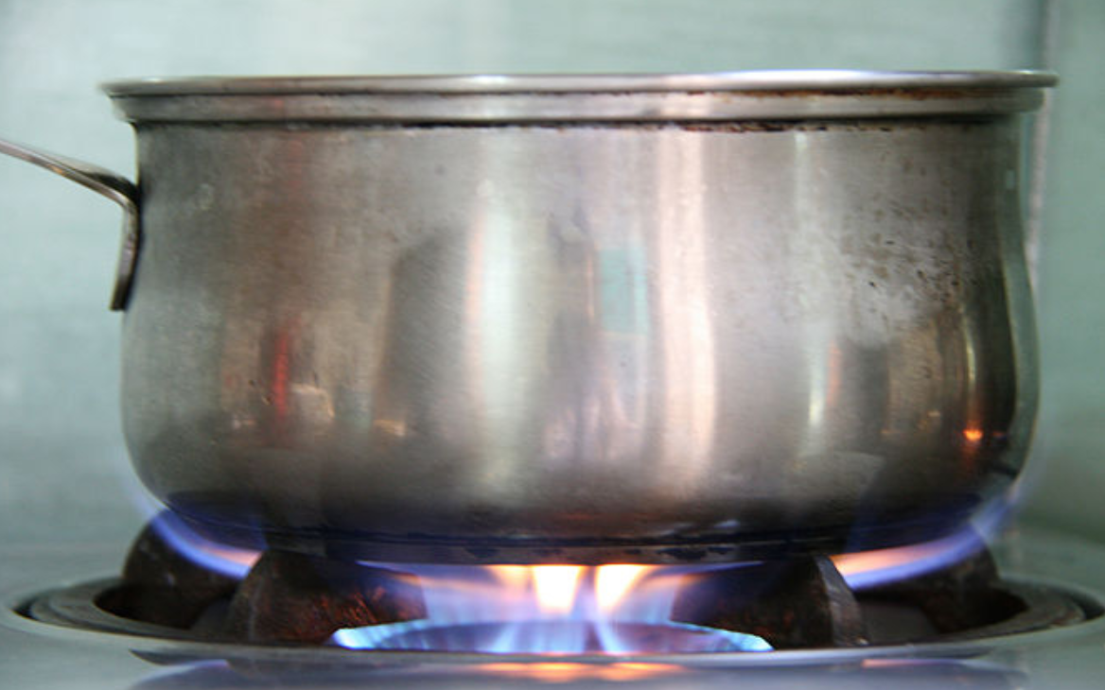

b) Your first day as a veterinarian, a client brings you his turtle who has ingested the last tablet from an unlabeled bottle of pain reliever. After taking a blood sample and doing some lab tests, you find out the drug had a 3:1 ratio of carbon to oxygen by mass. The three most common pain relievers are Advil (ibuprofen, C₁₃H₁₈O₂), Bayer (aspirin, C₉H₈O₄), and Tylenol (acetaminophen, C₈H₉NO₂). Which, if any, of the pain relievers did the turtle most likely swallow? Support your answer with both calculations and an explanation in words.

You want to make a rectangular box that weighs 2.0 pounds (lbs) and floats on water. The width and height of the box are each 5.0 cm long. Choose the minimum length of the box that will keep it afloat on the water. Show all work and explain in words why you chose your answer.
(Note: See the front page of your exam for useful conversions, equations, and/or constants.)

a) 180 cm b) 360 cm c) 9.7 cm d) 7.3 cm e) 38 cm

(Continue on to #17 on the next page.)
17. You have two rigid gas cylinders. Gas cylinder A has a volume of 48.2 L and contains N₂(g) at 8.35 atm at 25°C. Gas cylinder B has a volume of 22.0 L and contains He(g) at 25°C. When the two cylinders are connected with a valve of negligible volume and the gases are mixed, the pressure in each cylinder becomes 8.71 atm. (Assume no reaction when the gases are mixed.) Answer the questions below and show all work. Only complete and coherent explanations will receive full credit.

- How many nitrogen molecules are present?

b) What are the total number of moles of N₂(g) and He(g) present after the gases are mixed?

(Continue on to #17c-d on the next page.)

c) What was the beginning pressure of cylinder B containing only the He(g)? (i.e. before the valve was connected)

d) Think about the He(g) before and after the cylinders were connected. Graph the relationship between pressure and volume (without numbers) for the He(g) showing this change and explain your answer making sure to address the variables P, V, n, and T.

P

V

